Packet Tracer - Basic Switch and End Device Configuration

# Addressing Table

| **Device** | **Interface** | **IP Address** | **Subnet Mask** |
| --- | --- | --- | --- |
| Class-A | VLAN 1 | 10.10.10.100 | 255.255.255.0 |
| Class-B | VLAN 1 | 10.10.10.150 | 255.255.255.0 |
| Student-1 | NIC | 10.10.10.4 | 255.255.255.0 |
| Student-2 | NIC | 10.10.10.5 | 255.255.255.0 |

*Blank Line, No additional information*

# Objectives

=   Configure hostnames and IP addresses on two Cisco Internetwork Operating System (IOS) switches using the command-line interface (CLI).

=   Use Cisco IOS commands to specify or limit access to the device configurations.

=   Use IOS commands to save the running configuration.

=   Configure two host devices with IP addresses.

=   Verify connectivity between the two PC end devices.

# Scenario

As a recently hired LAN technician, your network manager has asked you to demonstrate your ability to configure a small LAN. Your tasks include configuring initial settings on two switches using the Cisco IOS and configuring IP address parameters on host devices to provide end-to-end connectivity. You are to use two switches and two hosts/PCs on a cabled and powered network.

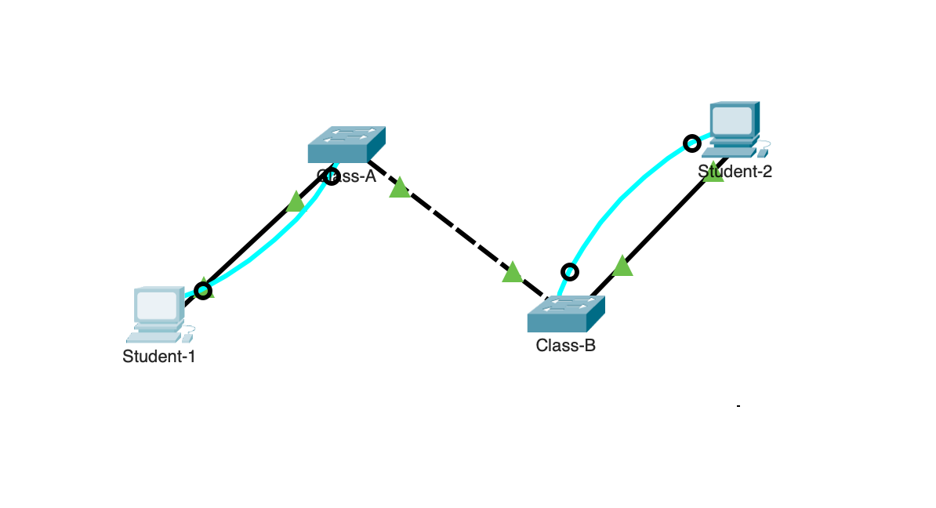

# Instructions

Configure the devices to fulfill the requirements below.

# Requirements

=   Use a console connection to access each switch.

=   Name **Class-A**and **Class-B** switches.

=   Use the **xAw6k**password for all lines.

=   Use the **6EBUp** secret password.

=   Encrypt all clear text passwords.

=   Configure an appropriate message-of-the-day (MOTD) banner.

=   Configure addressing for all devices according to the Addressing Table.

=   Save your configurations.

=   Verify connectivity between all devices.

**Note:** Click **Check Results** to see your progress. Click **Reset Activity** to generate a new set of requirements. If you click on this before you complete the activity, all configurations will be lost.

ID: 0220

*End of Document*